

From the Margins to the Core? Conference
Additional Programme Information

Day 1

Keynote Address

10.10–10.55
Title: The margins define the mainstream
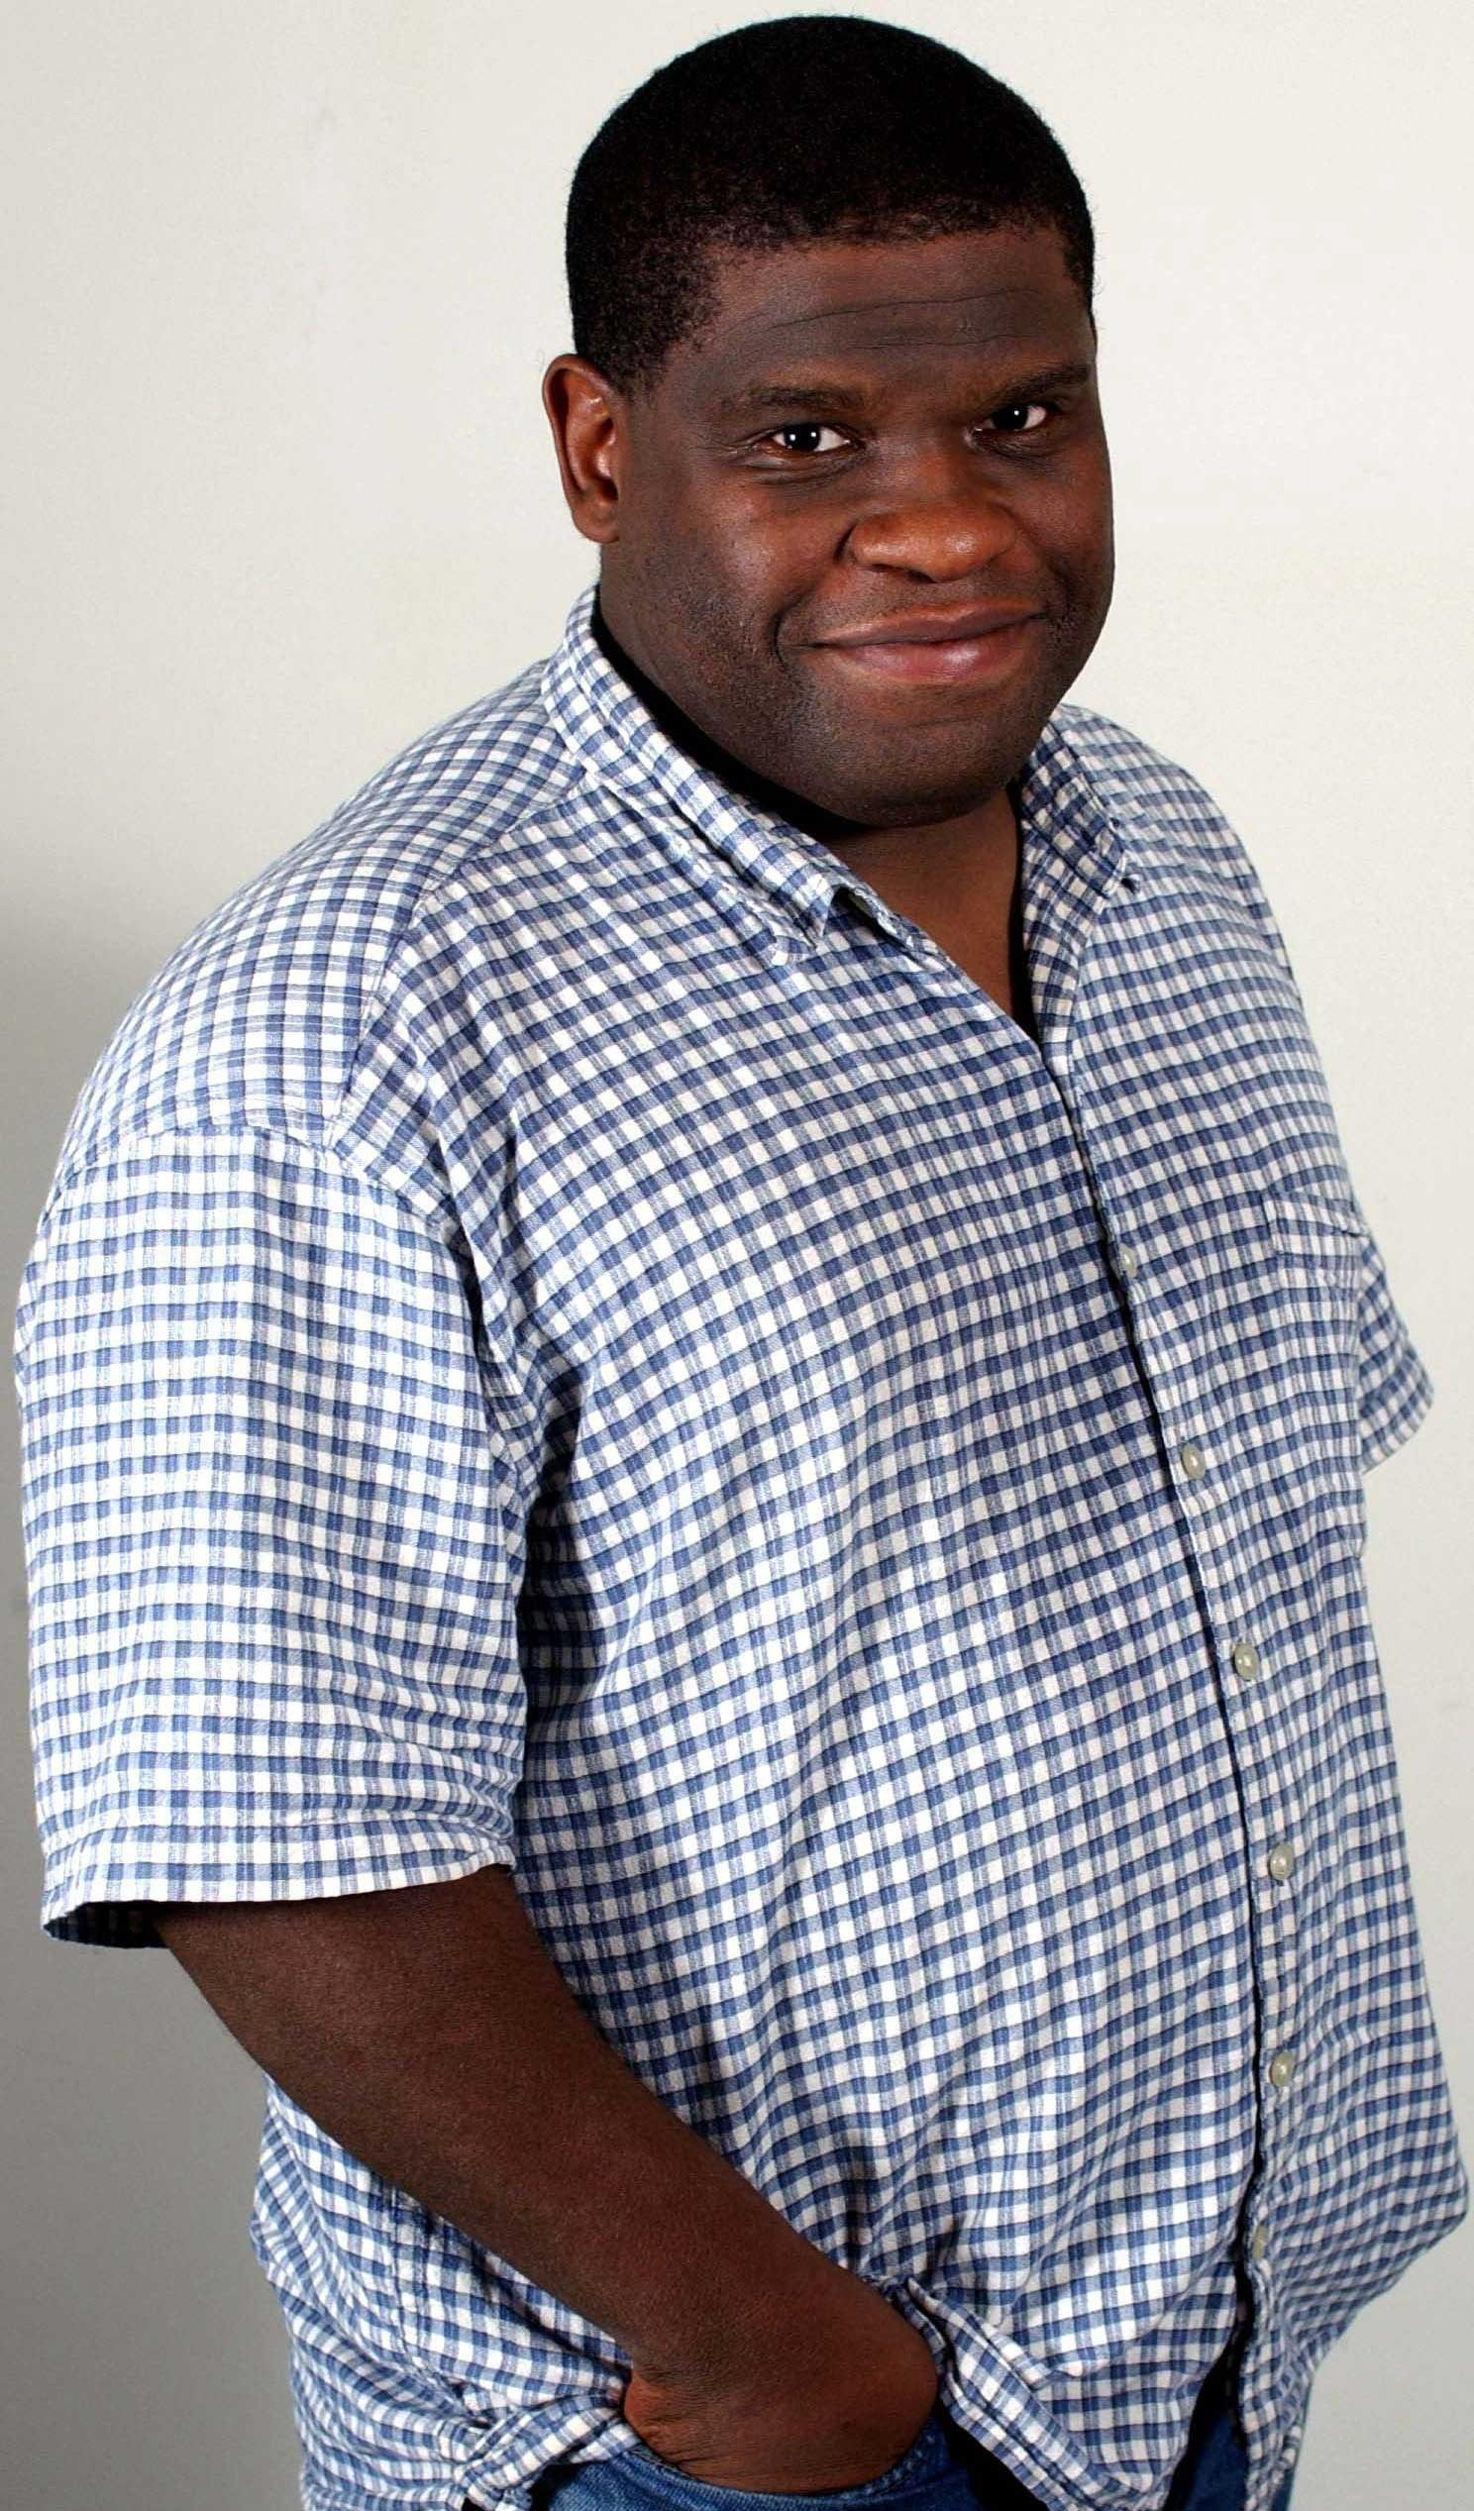
At any given moment an identity’s borders may shift and blur according to prevailing attitudes and political realities. Those who were black, Jewish or British yesterday may find themselves differently designated tomorrow. The recent case of South African sprinter Caster Semanya illustrates even sex is not as definite a category as many assume. It is precisely in those borderlands – the margins – that the mainstream is defined. Gatekeepers, both official and popular, attempt to police these frontiers. But humanity, ever dynamic and evolving, finds ways to evade their grasp. So what is marginal and what is mainstream are both relative to each other and in a constant state of change within themselves.

Gary Younge

Speaker: Gary Younge – Keynote address
Gary Younge is an award-winning author and columnist for The Guardian based in New York where he is also the Belle Zeller visiting professor of public policy and administration at Brooklyn College. His book, Who are We and Why does it matter, will be released by Penguin in June.

10.55–11.35
Panel discussion: Leaders in the cultural, museum & heritage sectors respond to Gary Younge

Chair: Ian Blatchford, Deputy Director, V&A
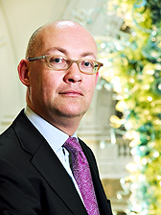
Ian Blatchford, who became Deputy Director of the Victoria & Albert Museum in December 2004, has worked for the Museum since April 2002 when he joined as Director of Finance & Resources.
He started his career in the City, working at the Bank of England and the merchant bankers Barclays de Zoete Wedd, before joining the Arts Council, where he was Deputy Finance Director. He then joined the marketing and
Ian Blatchford

design agency Cricket Communications as Financial Controller before becoming Director of Finance at the Royal Academy of Arts in 1996. He read law at Mansfied College, Oxford and is also a Fellow of the Chartered Institute of Management Accountants. He also holds an MA in Renaissance Studies from Birkbeck, University of London. Ian serves on the boards of the London Schools of Osteopathy and Sonic Arts Network and is a member of the Council of Imperial College.
Panel member: Makeda Coaston, Cultural and Heritage Facilitator & Enabler
Makeda Coaston is an arts and heritage consultant specialising in strategy development, programming and cultural mediation. She has worked with a range of museums, arts organisations and statutory agencies to ensure that programming and professional practices are inclusive of a wide range of interests and audiences. Her work is informed by over 25 years experience working in the arts, culture and media as a producer, project manager, publicist, fundraiser, researcher and journalist.

Panel member: Mark O’Neil, Head of Arts & Museums, Glasgow City Council
Mark O'Neill was appointed Head of Arts and Museums for Glasgow City Council in 2005, having previously been Head of Glasgow Museums since 1998. He began his museum career in Glasgow in 1986, working for a local trust to establish a museum in Springburn, a multiply deprived area in North Glasgow. In 1990 he was appointed Keeper of Social History in Glasgow City Council's museum service. He worked with the Education Department to set up the Open Museum, Glasgow's innovative and award-winning outreach service. He originated the concept for and established the St Mungo Museum of Religious Life and Art, one of only four museums of religion in the world. His main project for the past ten years has been the Heritage Lottery funded £30 million redisplay of Kelvingrove Art Gallery and Museum, the most visited museum in Britain outside London. Kelvingrove reopened on 11 July 2006 and received over three million visits within the first year of opening. He has published and lectured extensively on museum philosophy and practice.

Break Out Session: Embedding Diversity

12.00–13.00 Break Out Session 1a
Title: Getting to the heart of it
Diversity has become a keynote word in democracies as the understanding grows ever stronger that we should all have equal rights and entitlements, regardless of background, gender, or beliefs. Museums - as mirrors of society - should be putting issues of diversity at the heart of what they do. Diversity sits right at the center of social justice agendas, and is a keystone of public value. What are the challenges and what are the opportunities to deliver - for audiences, collections, staff, programmes and services? Drawing upon the sector’s initiatives and progress in general as well as developments at National Museums Liverpool in particular, the session will look at some of the strategies for getting to the heart of the issues and making things happen.

Rita Mclain will also discuss the need to embed community engagement work for it to make a positive, integrated and long-term difference to communities and our own organisations. It is important for museums to move from addressing diversity through one-off projects to embedding this work to promote positive organisational change. This session will explore incorporating diversity issues into strategic planning, the barriers and challenges to this agenda but also the mutual benefits of this approach.

Speaker: Amy de Joia, Executive Director of Development and Communications, National Museums Liverpool
Amy became Executive Director of Development and Communications at National Museums Liverpool (NML) in 2002, and her current role covers fundraising, marketing and communications, exhibitions, museum partnerships, and the development of NML’s commercial activities. Amy set up NML’s Diversity Action Group in 2005, and is the group’s Chair.
Amy is a member of a number of Liverpool and regional heritage and regeneration steering groups, and is a Board member of the National Wildflower Centre, the Liverpool Institute for Performing Arts and the American Museum in Britain.
Speaker: Dr Chrissy Partheni, Head of Museum Partnerships, World Museum Liverpool
Chrissy Partheni is an archaeologist and art historian and the Head of Museum Partnerships at National Museums Liverpool. Chrissy has previously worked with a variety of audiences at the Walker Art Gallery and World Museum Liverpool developing interpretations of collections and exhibitions.

Speaker: Rita McLean, Head of Museums and Heritage Services, Birmingham Museum and Art Gallery
Rita McLean has been Head of Birmingham Museums Service since 2006. She has worked in the UK museums and heritage sector for more than 25 years and during her career has been active in the development and application of a range of access and equalities programmes and workforce diversity initiatives.

12.00–13.00 Break Out Session 1b
Title: From Rhetoric to Reality
Our sector’s espoused values may reflect the spirit of the Equalities Legislation in their reports to stakeholders, but how do we translate that spirit into real action? To what extent does this rely on the work of a few committed individuals rather than in real aims and objectives embedded in and delivered by the organisation. This session will encourage discussion amongst participants, with questions being considered including
- how much has legislation brought about cultural changes?
- does the move to mainstream mean a lack of effective advocacy?
- why devote resources to the few rather than the many?

Speaker: Stephen Allen, Head of Learning & Programmes, National Museums Scotland
Stephen has worked in independent, local and national museums for the past 20 years including the National Portrait Gallery, London, Grange Museum of Community History and London Transport Museum. He currently serves on the Council of the Museums Association.

Speaker: Tamsin Russell, Organisational Development Projects Manager, National Museums Scotland
Tamsin has worked as a developer in the private and public organisations and for the last eight years has worked in the cultural sector in England and Scotland; leading on projects from staff surveys to internal communications; from business continuity planning to competencies. She is currently project managing the Equalities Project for National Museums Scotland.

Speakers: Rachel Hasted, Head of Social Inclusion Policy & Diversity, English Heritage
& Rosie Sherrington, Social Inclusion Policy Adviser, English Heritage
Rachel Hasted and Rosie Sherrington are the Social Inclusion Policy team at English Heritage. Both have been involved in different aspects of work to engage people who do not currently take part in ‘heritage’ activities.

12.00–13.00 Break Out Session 1c
Title: Sustaining the Impact
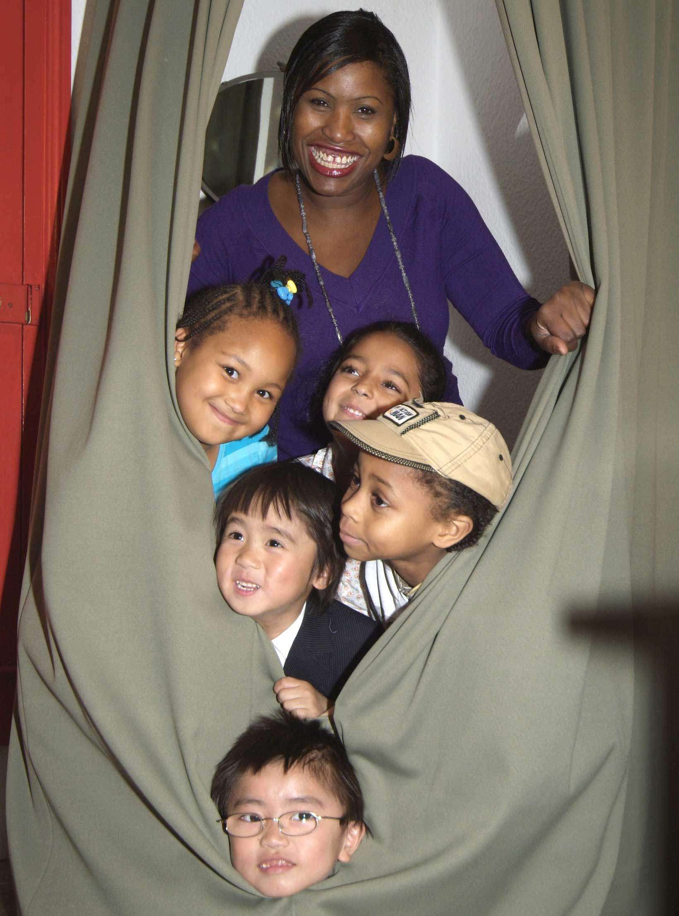
The session will explore inclusion work in two contrasting institutions: an arts and heritage service in a culturally diverse city and a large national organisation with a traditional membership base and properties mainly in rural areas. It will look at the impact of external funding streams and new staff on the core values of those organisations, and examine the ways that consultation and participation projects with people from diverse backgrounds have influenced the general visitor offer and audience profile. The session will also explore the challenges of sustainability and creating a lasting legacy in a climate of short-term funding.
Back to Backs in West Midlands.
Photo by Derek Wilbraham

Speaker: Alison Taylor, Senior Inclusion Officer, Herbert Art Gallery & Museum, Coventry
Alison Taylor has worked in museums since 1987 and from 2003 has led the Inclusion and Diversity team at the Herbert Art Gallery and Museum in Coventry. She has a particular interest in community history work and its potential to engage non-traditional audiences with museums.

Speaker: Dr Heather Smith, Head of Access for All, The National Trust
Heather’s role at the National Trust focuses on developing strategic direction in diversity and inclusion, including devising and implementing programmes of skill development and supporting activities with diverse communities to inform the Trust’s progress. She has also worked in a contemporary art centre and completed a PhD on museum and gallery accessibility for blind and partially sighted people.

12.00–13.00 Break Out Session 1d
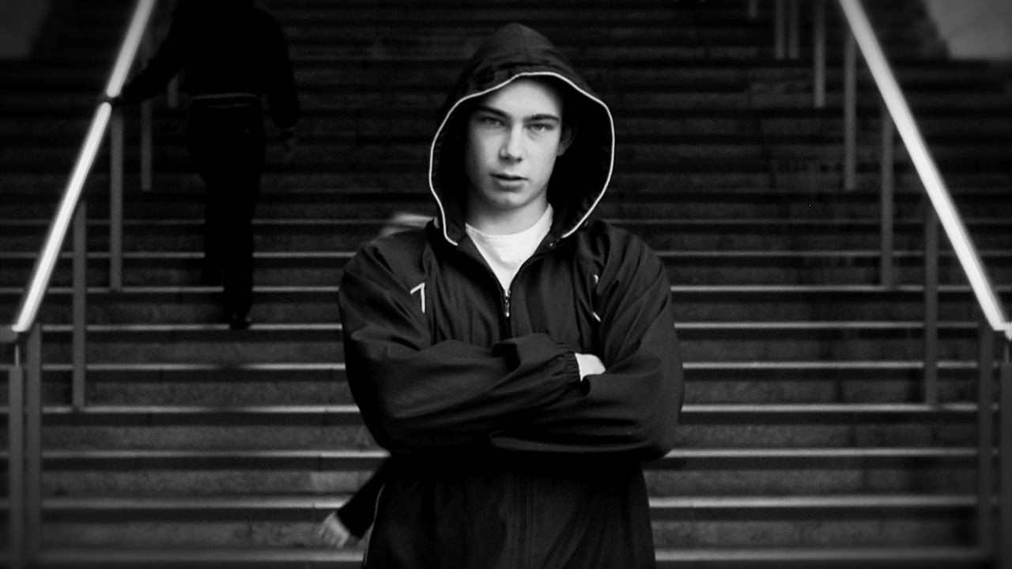
Title: Collections & Connections - implementing diversity in a way that connects with the public
This session will discuss the need to embed community engagement work for it to make a positive, integrated and long-term difference to communities and our own organisations. It is important for museums to move from addressing diversity through one-off projects to embedding this work to promote positive organisational change.
This is your history by 'Stephen Rudder'

This session will explore incorporating diversity issues into strategic planning, the barriers and challenges to this agenda but also the mutual benefits of this approach.

Lessons from developing the Museum’s gallery on the slave trade led to changes in the way the Museum is both structured and how it approaches its work. But has it really led to changes that could be said to have furthered diversity within the organisation? And what is it we are striving to represent? Are museums replicating ‘mythological models’ of culture in the belief that they are reflecting society when in fact they have no real connection with
the real people in the real world?

David Spence and Colin Prescod, Chair of the Institute of Race Relations, present findings on the impact of the gallery on the work of the Museum and how this informs debate on whether museums are able to implement diversity and equality in a way that connects with the public.

Speaker: David Spence, Director, Museum of London Docklands
In addition to his responsibilities at Museum of London Docklands, David Spence is also Director of Programmes at Museum of London. His role oversees the programming of exhibitions, events, communications and community engagement for both museums. He was responsible for the new gallery London, Sugar & Slavery that opened in 2007.

Speaker: Colin Prescod, Chair of the Institute of Race Relations
Colin Prescod is Chair of the Institute of Race Relations, London, and a member of the editorial working committee of the international journal, Race and Class. Colin served as a member of the (London) Mayor's Notting Hill Carnival Review Group, 2001-2003, as well as the (London) Mayor's Commission on African and Asian Heritage. He was founding-Chair, 1993-2001, of the DRUM, National Centre for British Black Arts and Culture, Birmingham.

Currently Colin is Chair of the Association for Cultural Advancement through Visual Art (ACAVA), London, and Chair of Carnival Village Ltd. In April 2004, he was appointed to the Learning Committee of the National Endowment for Science, Technology and the Arts (NESTA). He is also co-director of the not for profit, cultural animation company, 'Manifesta'.

Speaker: Wayne Modest, Keeper of Anthropology, Horniman Museum

Speaker: Finbarr Woolley, Assistant Director, Horniman Museum

Afternoon Session: Connecting or Competing Equalities?

14.00–14.30
Title: Unpacking gender
From costume collections to the odalisque, from displays of armour to dioramas, the traditional museum has been at the centre of the social construction of gender as well as the policing of gender boundaries. In the past decade, museums have increasingly been open to displays relating to gay and lesbian communities, as well as to displays focusing on woman’s changing roles in society.

Institutions merit praise for enhancing the inclusivity of collections and for drawing new audiences: however, their disruptions of gender binaries often remain incomplete, and there is a danger of replacing one set of exclusions for another when certain groups within or images of LGBTQ communities dominate.

Speaker: Professor Amy Levin, Associate Dean for College of Liberal Arts & Sciences, Northern Illinois University
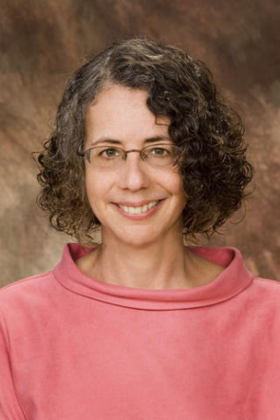
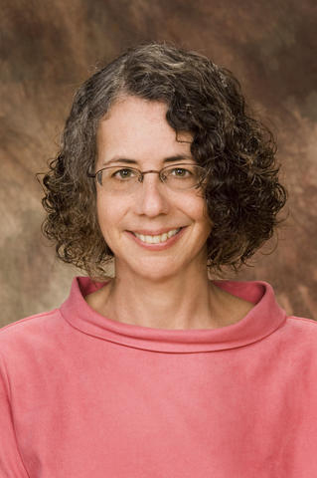
Amy Levin is Acting Associate Dean for the College of Liberal Arts and Sciences at Northern Illinois University, where she has served as Coordinator of Museum Studies, Director of Women’s Studies, and Professor of English. She is currently editing Gender, Sexuality, and Museums: A Routledge Reader, which will appear in 2010.

Amy Levin

14.30–15.30
Amy Levin
Title: A Question of Faith - the museum as a spiritual or secular space
Faith and belief is a core part of human heritage. It is also complex and how we portray sacred objects requires sensitivity for the expression to be authentic. Intangible heritage such as stories and rituals are also important and can often be overlooked. How far do such considerations impact on the way we conserve, display, interpret and organise public programmes? This panel will explore the relationship between art, science, culture and religion within this context; the role of the museum as a spiritual or secular space and how far museums can be a ‘neutral’ space which encourage interfaith/intercultural dialogue and understanding? Each panel member will give a 5 minute presentation followed by discussion.
Panel Discussion: Crispin Paine, Museums and Heritage Consultant (Chair), Dr Atul Shah, Lecturer, editor & broadcaster & founder of Diverse Ethics Ltd, David Anderson, Director of Learning & Interpretation, V&A (Secular voice), Mark O’Neill, Head of Glasgow Museums (Irish Catholic/Protestant perspective & responsible for St Mungo’s), Irna Qureshi, Researcher in cultural diversity amongst British Asian & Muslim communities

Chair: Crispin Paine, Museums and Heritage Consultant
Formerly a museum curator in Oxford and elsewhere, Crispin is now a museums and heritage consultant with a particular interest in religion. In 1999 he edited 'Godly Things: Museums, Objects and Religion', he is an editor of 'Material Religion: the Journal of Objects, Art and Belief', and is currently working on a book on the lives of religious objects in museums.

Panel member: Dr Atul Shah, Lecturer, editor & broadcaster & founder of Diverse Ethics Ltd
Dr. Atul Shah is founder of Diverse Ethics and author of ‘Celebrating Diversity’. He is a BBC broadcaster and expert on Diversity in the workplace and on the board of the UK Museums, Libraries and Archives Council.

Panel member: David Anderson, Director of Learning & Interpretation, V&A
David Anderson was born in Belfast and studied Irish history at Edinburgh University. After working as a history teacher in a state school, he became Education Officer at the Royal Pavilion Art Gallery and Museum, Brighton (1979) then Head of Education at the National Maritime Museum in Greenwich (1985). He joined the Victoria & Albert Museum as Head of Education in 1990. As Director of Learning and Interpretation at the V&A he is now manager of the V&A’s learning services, community programmes, and audience research and gallery interpretation; he also has responsibility for cultural policy, diversity and external partnerships across the V&A.

From 2003 to 2008, as co-Chair of the Exhibition Road Cultural Group, David Anderson shaped the development of a new organisation dedicated to development of cultural and educational programmes through partnership between 15 major institutions in South Kensington, including three national museums, three universities, the Royal Albert Hall, the Royal Geographical Society and the Ismaili Centre.

Panel member: Mark O’Neil, Head of Arts & Museums, Glasgow City Council
Mark O'Neill was appointed Head of Arts and Museums for Glasgow City Council in 2005, having previously been Head of Glasgow Museums since 1998. He began his museum career in Glasgow in 1986, working for a local trust to establish a museum in Springburn, a multiply deprived area in North Glasgow. In 1990 he was appointed Keeper of Social History in Glasgow City Council's museum service. He worked with the Education Department to set up the Open Museum, Glasgow's innovative and award-winning outreach service. He originated the concept for and established the St Mungo Museum of Religious Life and Art, one of only four museums of religion in the world. His main project for the past ten years has been the Heritage Lottery funded £30 million redisplay of Kelvingrove Art Gallery and Museum, the most visited museum in Britain outside London. Kelvingrove reopened on 11 July 2006 and received over three million visits within the first year of opening. He has published and lectured extensively on museum philosophy and practice.

Panel member: Irna Qureshi, Anthropologist, writer and oral historian

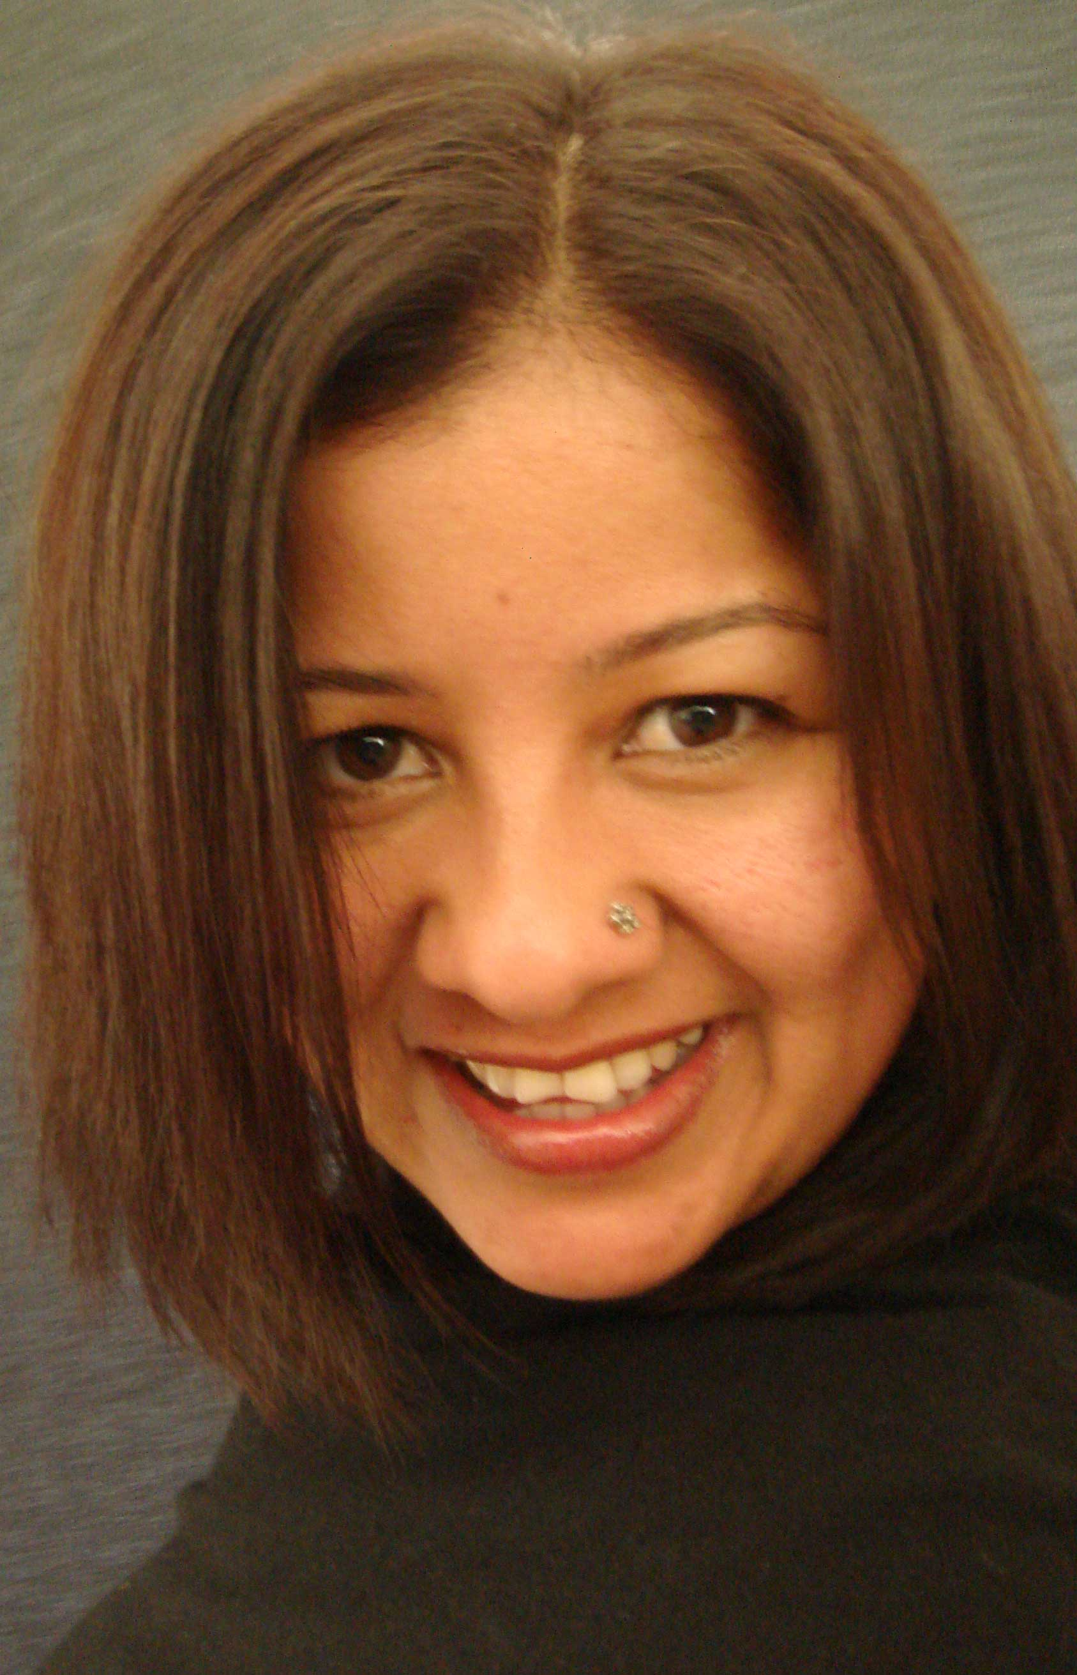
Irna is an anthropologist, writer and oral historian specialising in British Asian and Muslim heritage. Her experience includes research, consultation, audience development, community outreach, evaluation, oral history and curatorial work. She has worked on a variety of projects for TV and numerous government departments.

Irna has a special interest in multicultural broadcasting issues, as well as Bollywood and Lollywood. She has conducted research for the British Board of Film Classification on the attitudes of British Asian communities towards
Irna Qureshi

Bollywood cinema. She curated “Bollywood in Love” for the British Film Institute, which looked at love on and off screen through the ages in the Indian film industry, as well as several national oral history exhibitions about the heritage of Britain’s Asian communities.

Break Out Session: Connecting or Competing Equalities?

15.55–16.55 Break Out Session 2a
Title: Single equality strands are flawed
Reframing diversity is a practical discussion exploring the notion of holistic diversity awareness for the arts. It works on the hypothesis that for organisations to get to know and attract communities outside they should get to know and understand the community within the work place. This pilot exercise follows 3 years of working and researching diversity best practice across the creative and heritage sectors. The session draws on experiences in response to the ‘Diversity Workshop’ model; repercussions of The Equality Act and The Equality in Employment; and best practice in preparation for the Single Equality Bill.

Speaker: Tim Redfern, Creative Director, Pride Legacy Project
Tim is a freelance diversity consultant specialising in LGBTQ cultural programming. Over the last 3 years he has researched attitudes to representations of LGBTQ culture across the creative and heritage sectors. He has worked with Royal Court Theatre, Royal Opera House, Tate Modern and Victoria & Albert Museum among others. Tim is also a performance artist.
15.55–16.55 Break Out Session 2b
Title: Race and Gender: Diverging histories – retrieving and documenting women’s movements of the 70’s
This discussion will examine the work of two separate projects that have been using oral history to document significant narratives around women’s history in the 20th century; The Heart of the Race: Oral Histories of the Black Women's Movement, Black Cultural Archives, and The Women’s Liberation Movement History project, The Women’s Library.

The discussion will be an opportunity to create a dialogue around questions of race and gender and some of the challenges in documenting two specific women’s movements, through the accounts and testimonies of women actively involved. The long tradition of collection development has meant that there is limited sources available and have often been developed as part of traditional elite perspectives. These case studies illustrate the very exercise of retrieving Black and Asian women’s history in all of its complexity, and also reveals our own interactions with history and how audiences begin to define and digest memories of a period in history and a political movement.

Speaker: Mia Morris, Oral history project co-ordinator, Black Cultural Archives
Mia Morris works part time with the Black Cultural Archives as project co ordinator for the Oral History Project on the Black Women’s movement entitled Heart of the Race. This project includes a team of trained volunteers who act as interviewers or transcribers for the project. Mia convenes monthly events with invited speakers for the volunteers which acts as a focus group. The project also has a steering group chaired by Maureen Roberts from the London Metropolitan Archive. So far the project has interviewed 30 women in Jamaica, Bristol, Birmingham, Manchester, Oxford and London. More details about this project can be found on the BCA website www.bcaheritage.org.uik or visit the project blog www.heartoftherace.blogspot.com.,

When Mia is not working at the Archives she runs the company Well Placed Consultancy www.wellplaced.co.uk. Well Placed Consultancy are owners of www.black-histoyr-month.co.uk. Mia also edits the award winning publication Black History 365.

Speaker: Rachel Cohen, Women's Liberation Network Facilitator, The Women's Library

Speaker: Gail Cameron, Curator, The Women's Library

15.55–16.55 Break Out Session 2c
Title: Disability – national to institutional policy to good practice
This workshop will assess to what extent the UK has developed a coherent national approach towards the cultural equality of disabled people in museums. It will enquire into how DCMS and its funded bodies engage with international and national policies which assert the cultural rights of disabled people, including the Disability Equality Duty.
This talk will discuss whether there needs to be a reassessment of structural change to bring about lasting and significant improvement.
The talk will also focus on implementing policy at an institutional level and putting this into practice on the ground.

Speaker: Marcus Weisen, Consultant, Museums and Galleries without Barriers
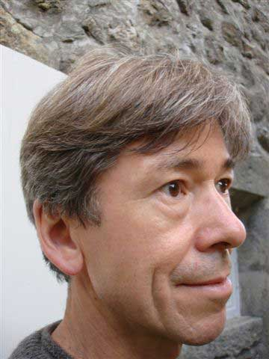
Marcus promotes cultural equality of disabled people as a consultant and works internationally. He is Director of the Jodi Mattes Trust for accessible digital culture (www.jodiawards.org.uk) and Content Director for the ‘In Touch with Art 2010’ conference (www.st-dunstans.org.uk/in_the_community/public_shows.html).
He was Health and Disability Adviser, MLA (2002-2007) and Arts Officer, RNIB (1987-2002).

Marcus Weisen

Speaker: Barry Ginley, Disability & Access Officer, V&A
Since November 2002, Barry Ginley has worked as Disability and Access Officer at the Victoria & Albert Museum in London. The role is varied, dealing with all aspects of the Museum's work, including developing policies and strategy, design of galleries, staff training, and managing talks programmes. Prior to this position, Ginley was a consultant at the Royal National Institute of the Blind and several property service companies.

Since 1994, after an eye operation went wrong, Ginley has been visually impaired. In 2001 he studied part-time at the University of Reading and has completed the MSc in Inclusive Environment Design and Management.
As the Head of Disability and Social Inclusion at the V&A, Ginley wishes to improve access for all visitors to the collection.

Speaker: Maureen McKarkiel, Programme Manager, Mental Health, V&A
Maureen has worked for many years in community arts where she has held a variety of roles, including an Arts Consultant for the NHS, a Spanish Oral Historian and Further Education Literacy Lecturer. She has been instrumental in introducing and developing the programme of events for mental health service users at the V&A.

15.55–16.55 Break Out Session 2d
Title: Young People – Let’s Start Again
Can museums and galleries create a genuine platform for young people to engage with collections and address how social and cultural barriers can be challenged?
Henrietta Hine and members of the Courtauld Youth Council will present ‘Animating Art History’, a widening participation project between The Courtauld Institute and University of the Arts London. They will demonstrate successful ways of offering young people challenging opportunities, high levels of engagement and a learning environment where they are trusted and their views are respected at all levels of the institution.

Stretch has been working in partnership with Leeds Museum Service for the past 2 years with hard-to-reach young people, young offenders and looked after children. How we engage these difficult young people is the focus of the presentation. It is a case study and short film followed by discussion. Are we listening to young people? Are we missing the point entirely? Why should the heritage sector bother at all? To make museums and collection relevant to their lives we need to start again, with their own collection, their own spaces, their own language, objects and exhibitions.

Speaker: Henrietta Hine, Head of Public Programmes, The Courtauld Institute of Art
Henrietta Hine joined The Courtauld Institute of Art as Head of Public Programmes from the Whitechapel Gallery in 2007; she has developed and delivered training seminars in museums and galleries across the UK, Switzerland and South East Asia for the British Council and has a background in experimental art practice.

Speaker: Carlotta Goulden, Arts Charity Director, Stretch
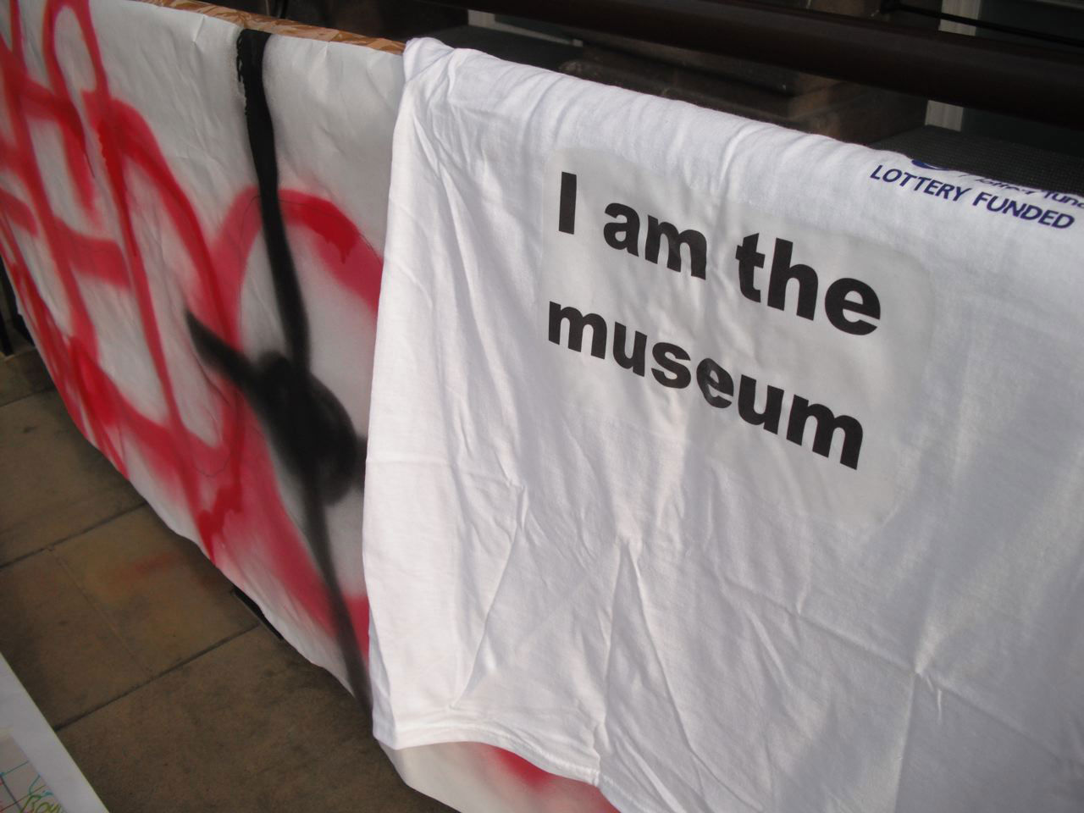
Carlotta Goulden is the founder and director of Stretch, an arts charity that has been delivering museum projects to marginalised groups since 2003. Stretch has worked with the offending community on a national scale and presented work at international conferences and university seminars. Carlotta has a PGCE and an MA in Museum and Gallery Education.

Photo by Carlotta Goulden

Speaker: Nick Cass, Art Teacher & freelance practitioner, Leeds
Nick Cass is an interdisciplinary practitioner working across the fields of Fine Art, Museum and Gallery Education and Higher Education. He has exhibited widely and works freelance for a number of clients including Stretch on a number of projects. He is a Trustee of the charity.

15.55–16.55 Break Out Session 2e
Title: Missing Out – Heritage and Social Class
How we feel about heritage appears to be closely linked to our education and social status. The Taking Part national survey shows that about 79% of people in higher socio-economic groups engage with heritage while only 54% of those in lower socio-economic groups do. This session examines what heritage offers to people of different socio-economic groups. English Heritage has undertaken research and held a conference in March 2009 to discuss the results with community heritage groups and institutions. This session is an opportunity to share experience on engagement with people in lower socio-economic groups.

Speakers from English Heritage: Laura Clayton, Head of Social and Economic Research,
Miriam Levin, Head of Outreach, Rachel Hasted, Head of Social Inclusion Policy & Diversity,
Rosie Sherrington, Social Inclusion Policy Adviser
Laura Clayton is the Head of Social and Economic Research for English Heritage, Miriam Levin is Head of Outreach and Rachel Hasted and Rosie Sherrington are the Social Inclusion Policy team. All have been involved in different aspects of work to engage people who do not currently take part in ‘heritage’ activities.

Performance

17.10–17.55
Title: From Freak to Clique
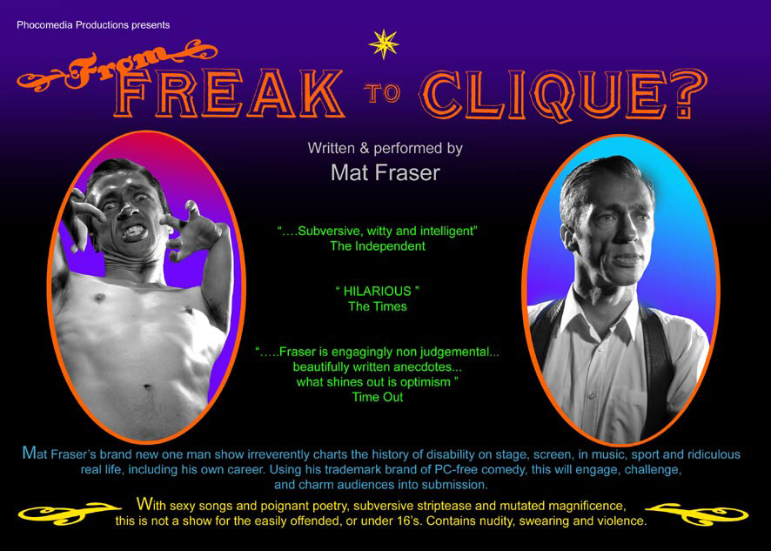
‘From Freak To Clique?’, whilst seeming to be an alternative title to this conference, is actually the title of Mat Fraser’s new show. It cheekily charts the history of disability portrayal on stage, screen, and ridiculous real life, including his own career. Using his trademark blend of un PC comedy, poignant words and songs, poetry and characters, this will challenge and entertain in equal measures. From Tom Thumb to Top Gun, from freak shows to clique ho’s, from Sandy (Crossroads) to Andy (Little Britain), it covers all the major players in the classic one man show format. Not for the easily offended, or under 16’s.

Performer: Mat Fraser

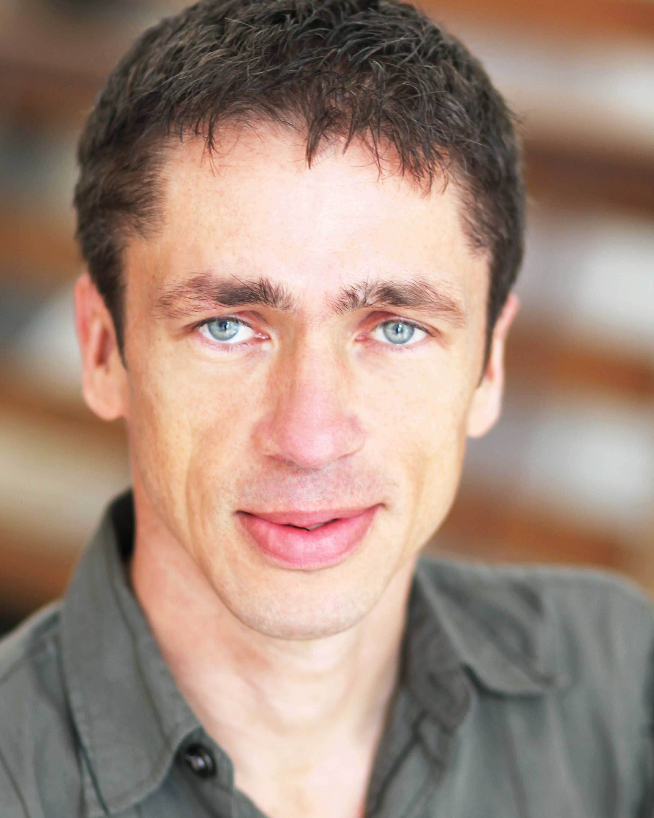
Mat Fraser is one of the U.K.’s best known disabled performers. From recent drama ‘Cast Offs’ on Channel 4, the smash hit violent action film ‘Unarmed But Dangerous’, he also has a wealth of his own stage shows, such as the award winning ‘Thalidomide!! A Musical’.
Go to www.matfraser.co.uk for all info.

Mat Fraser

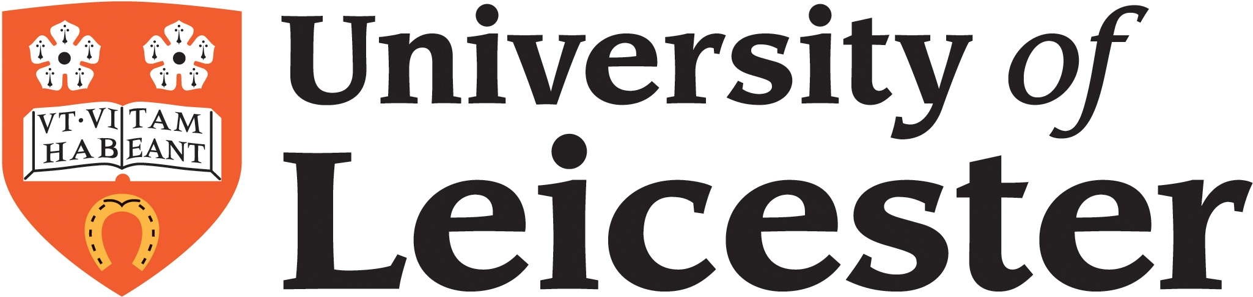

Jointly organised with University of Leicester’s School of Museum Studies

