

From the Margins to the Core? Conference

Additional Programme Information

Day 3

Drivers for Change

09.30–10.40
Title: A Change of Heart: Fred Wilson’s Impact on Museums
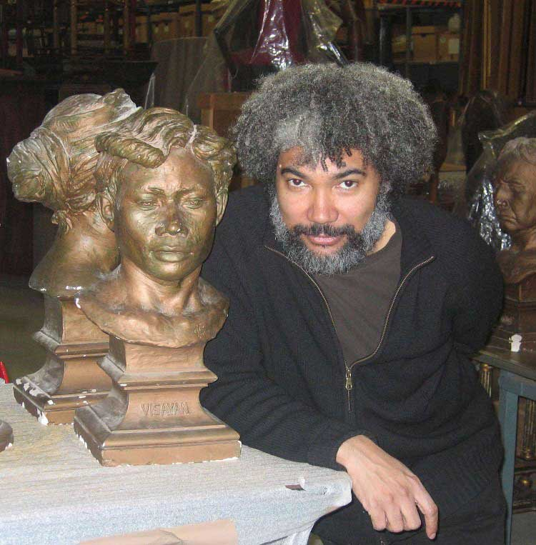
Fred Wilson will speak about the way his 1992 project Mining the Museum at the Maryland Historical Society changed the relationship between the staff and the community, the historical society and other local museums, the professional staff and the support staff, black and white. Janet Marstine will consider how Wilson’s collaborative process contributes to a new museum ethics by shaping individual and institutional values. By analyzing data from interviews she conducted with Wilson’s collaborators in two interventions, she will demonstrate that these projects have helped move institutions
towards greater diversity, equality and social engagement.
Fred Wilson, Photo by Barbara Thompson
Courtesy of Hood Museum of Art, Dartmouth College

Speaker: Fred Wilson, Conceptual Artist, New York
Fred Wilson's work has been featured in over 100 group exhibitions, including the 50th Venice Biennale (2003) as the American representative, the Whitney Museum of American Art Biennial Exhibition (1993), and the 4th International Cairo Biennale (1992). He has had over twenty-five solo museum exhibitions internationally, and has been the recipient of numerous honors and awards. Among them, the John D. and Catherine T. MacArthur Foundation Award (the ‘Genius Grant’), Chicago (1999). Fred Wilson is represented by Pace Wildenstein Gallery, N.Y., and currently lives and works in New York City.

Speaker: Janet Marstine, Director, Institute of Museum Ethics, Seton Hall University, New Jersey

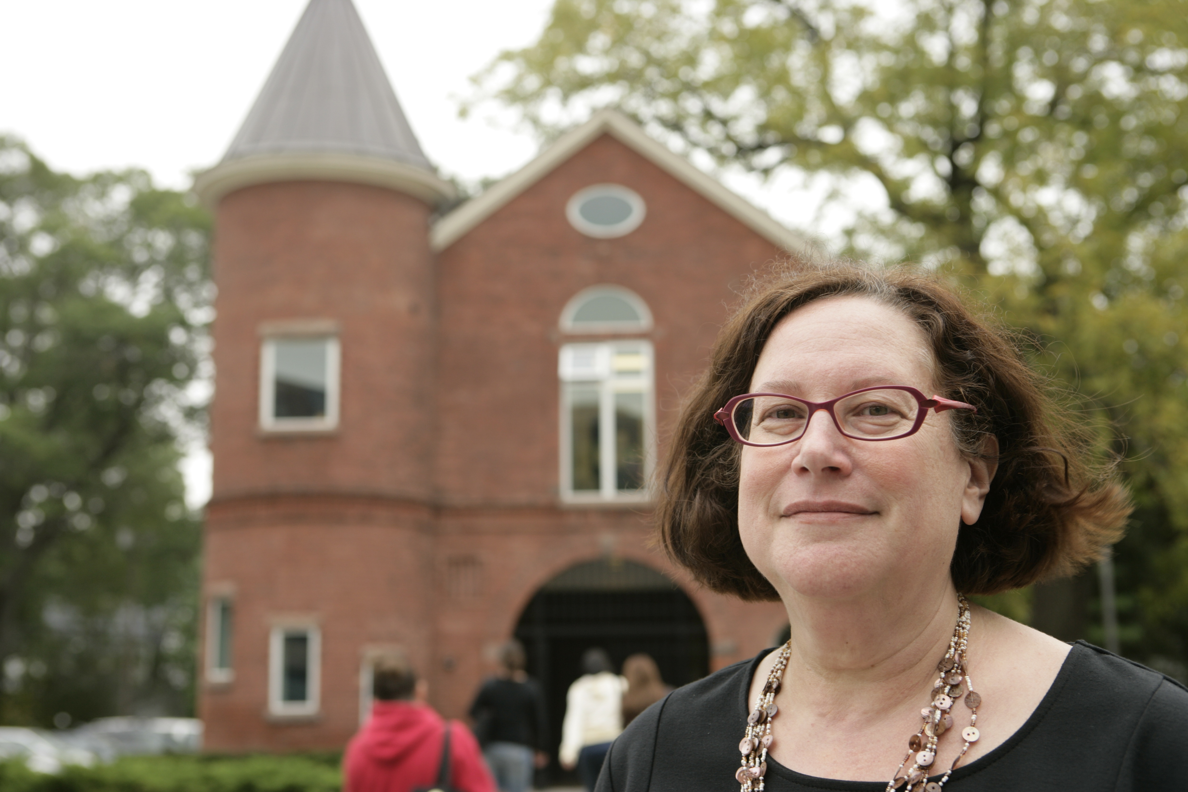
Janet Marstine is Director of the Institute of Museum Ethics at Seton Hall University for which she received a three-year Institute for Museum and Library Services Grant. She is editor of New Museum Theory and Practice: An Introduction (2005) and is currently editing Routledge Companion to Museum Ethics: Redefining Ethics for the Twenty-First Century Museum.
Janet Marstine © Seton Hall University

10.40–11.05
Title: Moving forward on all fronts?
A review of how far and in what way issues of diversity have moved from the margins to the core within the context of a national museum? How far have we been successful in driving forwards on equality issues simultaneously and what have been the key drivers for change both internally and externally? The talk will draw on the major HLF funded project Capacity Building and Cultural Ownership- working with culturally diverse communities and address other key issues such as policy making, decision making structures, the role of departments and staff at all levels of the organisation, networking and partnership. It will look at lessons learnt and explore future drivers for change.

Speaker: Eithne Nightingale, Head of Diversity Strategy, V&A
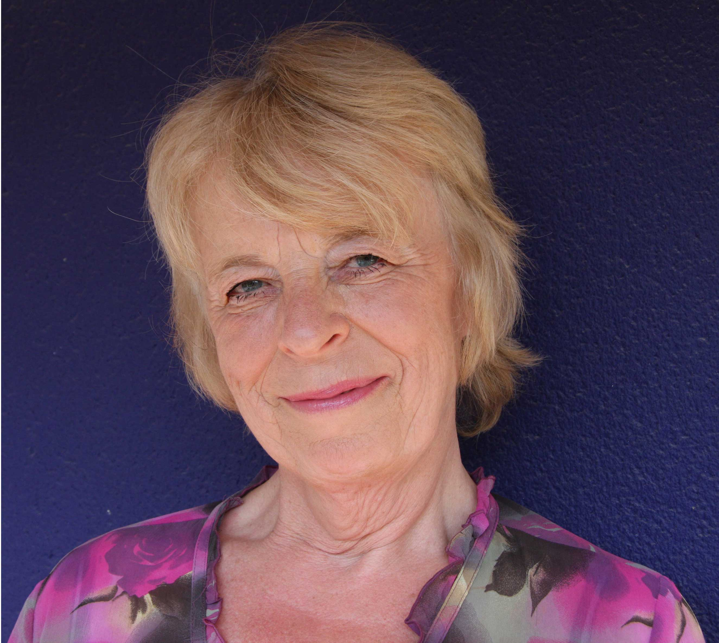
Eithne Nightingale is Head of Diversity Strategy at the V&A where she takes a lead on developing and implementing a Museum wide access, inclusion and diversity strategy and as it affects all areas and activities of the Museum. She initiated the 1 million pound HLF funded Capacity Building and Cultural Ownership Programme – working with diverse communities which encompassed research into collections, public programming and the development of partnerships
Eithne Nightingale

with black and ethnic minority organisations. She has written and lectured on diversity in museums both in the UK and internationally. Eithne has worked in race relations, community development, regeneration and post 16 education and museums for over 30 years. She has worked as a consultant in Bangladesh and South Africa and before coming to the V&A, she ran the community and adult education service and regeneration programmes in the London Borough of Hackney, one of the most diverse and socio-economically deprived areas in the UK. She is also a photographer and a travel/fiction writer.

Break Out Session: Drivers for Change

11.30–12.30 Break Out Session 1a
Title: Leadership and Diversity ‘Making it Happen’
Cultural institutions need to widen the pool of talent and expertise from which board members are drawn. In spite of the Nolan rules which ensure transparency when board members are recruited, key players in the governance of state-funded cultural organisations remain overwhelmingly white, middle-class, middle aged and male.
This matters because Boards set the tone. And diversity matters because it has a positive impact on the ability to narrate stories in new ways for broader appeal. The session will outline what is being done to address the issue.
‘Making it Happen’ is a ground breaking new DVD, produced by the V&A, which explores good diversity practice in the heritage and cultural sector and the wider world of business.

The DVD presents a broad spectrum of cultural and corporate leaders who share with the viewer diversity and equalities concepts and theory; common pitfalls for leadership; examples of good practice and a range of innovative and entrepreneurial ideas & approaches to what can be a complex area of work.

The purpose of the DVD is to move the viewer to informed, responsive and relevant thinking which matches the pace of current and future organisational and economic change.
‘Making it Happen’ trials have received excellent feedback for the DVD’s multiple applications as a training and development tool. The session will introduce some techniques for discussing the issues of embedding diversity into leadership and day to day business. It is one of the outcomes of the HLF funded programme Capacity Building & Cultural Ownership working with culturally diverse audiences.

Chair: Roy Clare, Chief Executive, Museums, Libraries & Archives Council
Speakers: Veronika Harris, Head of Training and Development, V&A
& Margot Rodway-Brown, Consultant, Rodway Brown Associates

Chair: Roy Clare, Chief Executive, Museums, Libraries & Archives Council
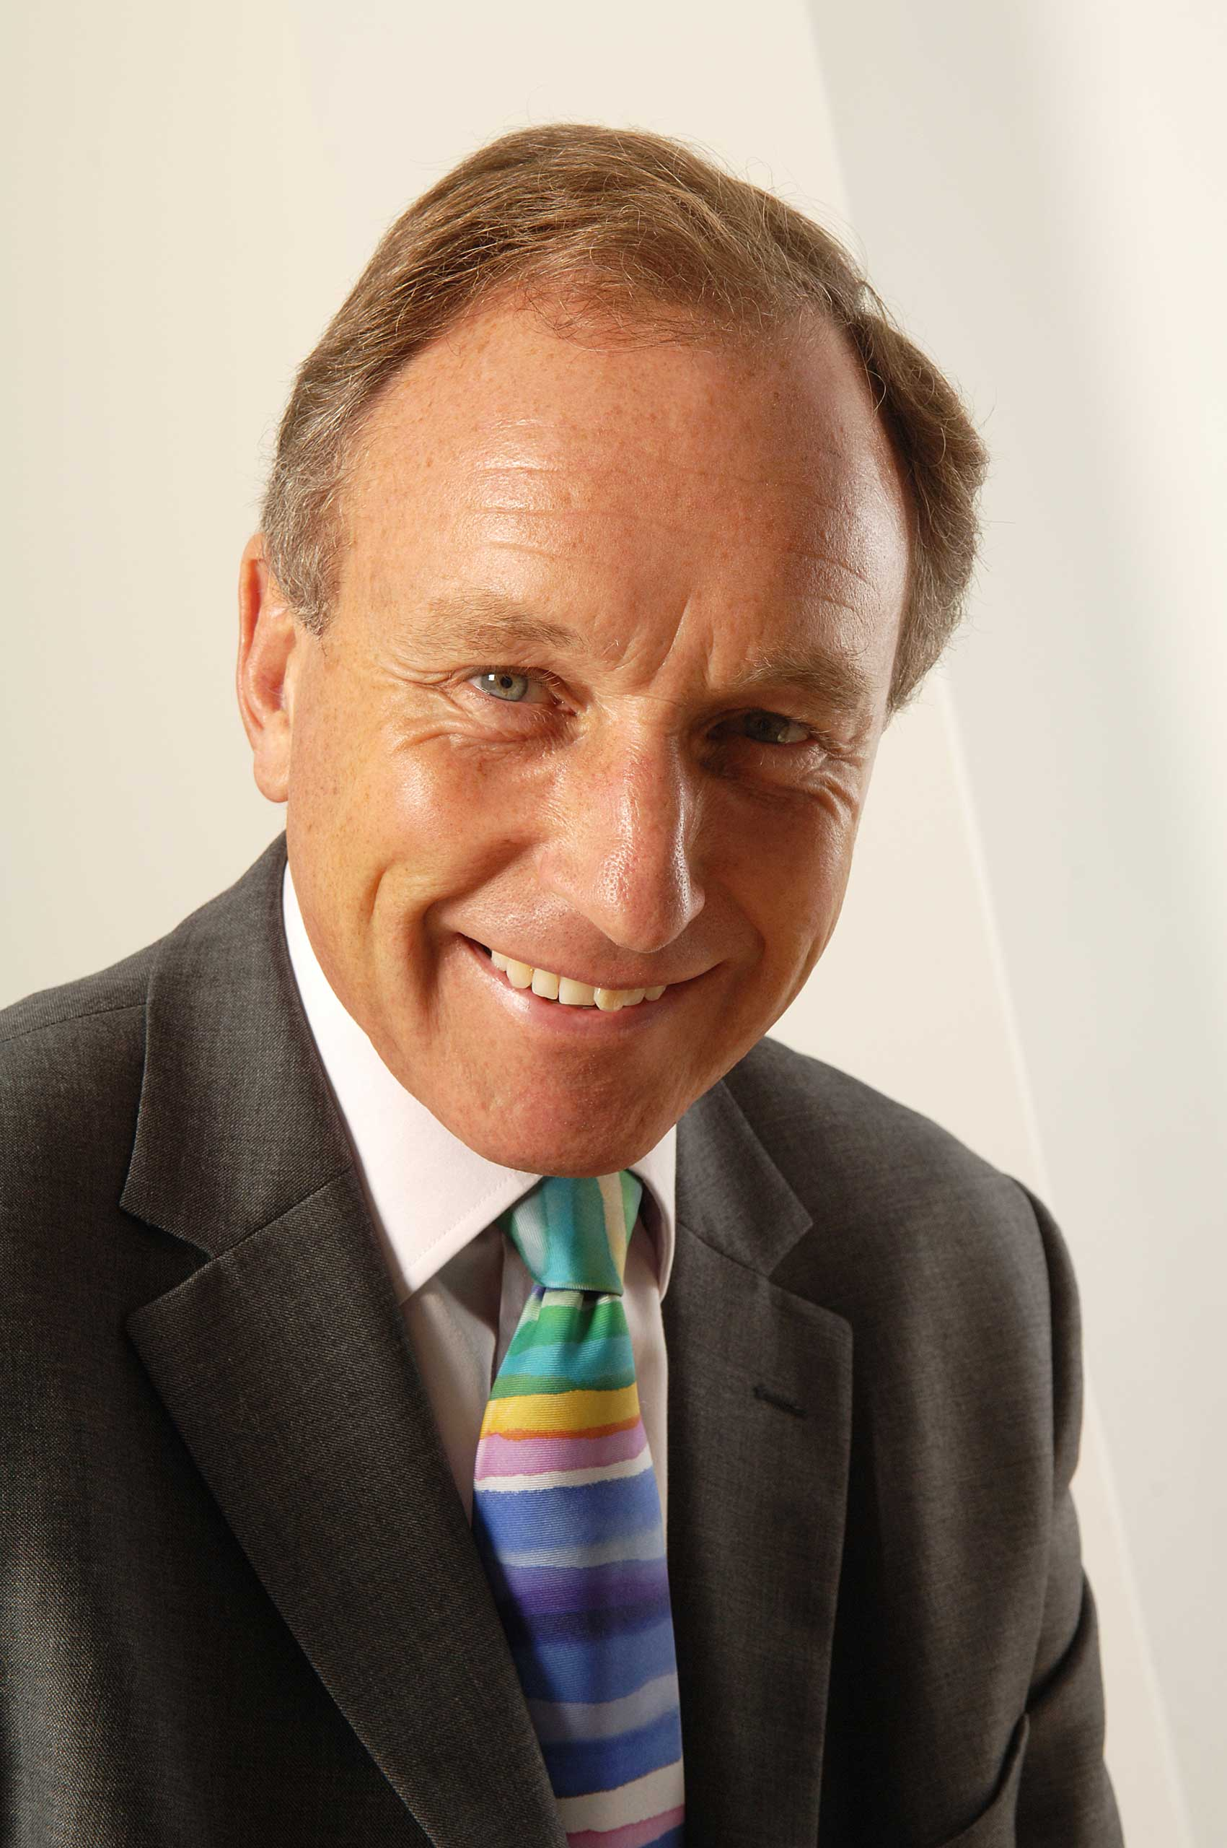
Roy Clare CBE has been Chief Executive of the Museums, Libraries and Archives Council (MLA) since September 2007. He has shaped a substantial transformation of the MLA where he now leads a team of expert staff who are equipped to work nationally and locally with government at all levels, with professional bodies and in concert with a variety of partners.

Roy Clare

Speaker: Veronika Harris MSc FCIPD FRSA CERT ED
Head of Training and Development at the V&A

Veronika has 30 years experience in training and development and organisational consultancy, developing programmes for a range of organisations in the public and private sector. Her career began as a teacher of textile design, printing and fashion and working in retail as a Training Manager. From there she worked in Local Government as Training Manager and Head of HR, supporting the changes in modernising Government by implementing Best Value and Diversity.

She joined the V&A in April 2000 and has successfully gained the Investors in People Award for the whole organisation and built major partnerships with other National Museums for management & leadership programmes . She has developed and gained national status for V&A museum qualifications through the V&A Cultural Heritage Assessment Centre and commissioned a Leadership and Diversity film for the sector. A member of the V&A Diversity Strategy group and board member of the American Museums Association Annual Conference 2005/6 she has been key speaker at ICOM , AAM and Smithsonian Training Council 2007, Chair of the Museums Association Conference Nov 2008. Member of project team Abu Dhabi Cultural Heritage professional museum education programme, January 2009 and tutor on the Clore Leadership Programme 2009.

11.30–12.30 Break Out Session 1b
Title: Collecting the Margins at the Core? Representing ‘Africa’ in the collection
The collections of the Victoria and Albert Museum (V&A) have long been presumed to exclude the cultural products of the African continent. However, a recent research project funded by the Heritage Lottery Fund – part of the Capacity Building and Cultural Ownership initiative - found this presumption to be unfounded: Like all British museums, the V&A’s collections offer a rich seam of evidence relating to the history of the African continent and to its changing relationship with Britain. But to what extent could this discovery be ‘mainstreamed’ into the institution’s practices of collecting, display and interpretation – and how is this challenge being addressed by other museums?

Speaker: Helen Mears, Keeper of World Art, Royal Pavilion & Museum, Brighton & Hove (Previously Researcher of African Collection, V&A)
Helen Mears is the Keeper of World Art at Royal Pavilion & Museums, Brighton & Hove. Previously she was African Diaspora Research Fellow at the Victoria and Albert Museum. The post was part of a Capacity Building and Cultural Ownership and initiative funded by the Heritage Lottery Fund.

11.30–12.30 Break Out Session 1c
Title: The role of community heritage
An exploration of the work of UK based organisations Black and Asian Studies (BASA), Anglo Sikh Heritage Trail, Black Cultural Archives and Institute of Jainology. What are the similarities or differences in approach between these organisations and how far does their work fill a gap not fulfilled by the 'mainstream'? What are the mutual benefits of collaborative working between the ‘mainstream’ and the ‘community’ sectors and how effective are they in achieving this? Do such organisations have a role in influencing the ‘mainstream’ and how effective are 'mainstream' organisations in recognising and utilising external expertise? Each organisation will give a 5 minute presentation followed by discussion.

Panel Discussion: With representatives from; Anglo Sikh Heritage Trail, Black & Asian Studies Association, Black Cultural Archives and Institute of Jainology

Panel member: Harbinder Singh, Director, Anglo Sikh Heritage Trail

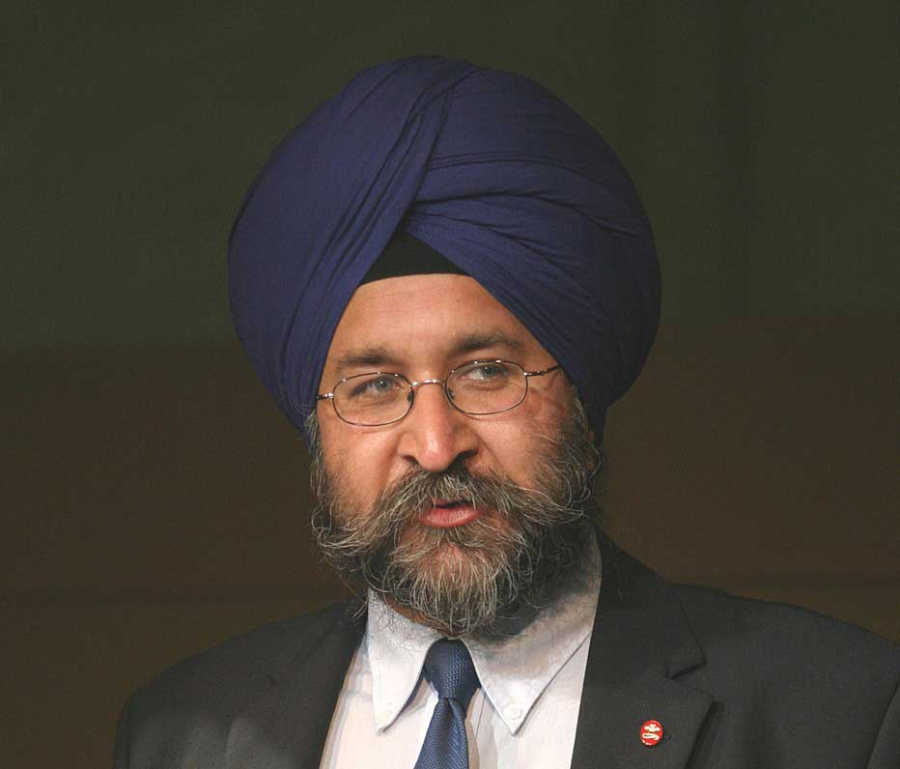
Harbinder Singh is the founding Director of the Maharaja Duleep Singh Centenary Trust, Britain’s first Sikh heritage based organisation. MDSCT commissioned the memorial statue to Maharaja Duleep Singh & collaborated with the Victoria & Albert Museum in the 1999 ‘Arts of the Sikh Kingdoms’ exhibition. He has overseen the conception and launch of the Anglo Sikh Heritage Trail which now covers the UK.
Harbinder Singh

Panel member: Cliff Pereira, Secretary, Black & Asian Studies Association

Panel member: Rajiv Anand, IOJ Consultant, Institute of Jainology
Rajiv has been working in the field of community heritage, education arts and museums over the last 15 years. He started this work as a Community Museums Officer at Kirklees Museums Service and then re-located to London to work as Diversity Officer at MLA Council. Rajiv has also worked as Youth and Arts Officer for Race Relations Think Tank Runnymede Trust and as the Team Leader Cultural Diversity and South Asian Officer for the V&A. At present he is working as a Museum Consultant on JAINpedia managed through Institute of Jainology (IoJ). This is a large national project working in partnership with V&A, British Library, Bodleian Library University of Oxford and Wellcome Trust on managing major Jain exhibitions from these collections and a subsequent series of related events.

Panel member: Kimberley Keith, Black Cultural Archives

11.30–12.30 Break Out Session 1d
Title: Diversity, decision making and democracy
The presentation is based on the three year evaluation of the V&A Capacity Building & Cultural Ownership cultural diversity project undertaken by Safe Hands Management Ltd funded by the Heritage Lottery Fund. In particular the use of social network analysis as an evaluative tool to determine the social patterns of interaction, and levels of penetration between staff in the museum when it comes to engagement with the diversity agenda will be explained. The implications of non formal interactions for the formal management arrangements , structures and systems will be discussed in the context of institutional cultural change.
The museum enterprise is increasingly understood as a reciprocal engagement with communities. Yet despite the democratic rhetoric, museums have not yet fully succeeded in creating ethical, sustainable partnerships. Lynch argues that they have failed to realise that the `contact zone' is a `political space', where issues of power and conflict come face to face, and offer only what Cornwall calls `empowerment lite'. Lynch proposes instead that museums could begin to understand their community partners as active agents, recasting the role of participants, from, `users and choosers to makers and shapers'. and suggests, through emerging new museum practice, how this might be achieved.
Speaker: Professor Simon Roodhouse, Safe Hands (Management) Ltd
Professor Roodhouse has direct experience of management in the educational and cultural fields as the first Chief Operating Officer for the University Vocational Awards Council, and latterly as the founding Director of the Museum Training Institute where he developed and established national occupational standards of competence for the heritage sector. His senior management experience in higher education includes Dean of the School of Art and Design, University of Derby, Head of the School of Creative Arts, Northumbria University and Head of Academic Development, Bretton Hall, University of Leeds

Currently he is adjunct Professor at University of Technology, Sydney, and Professor in the Institute for Work Based Learning, Middlesex University as well as running his own consultancy, Safe Hands Management Ltd. Until recently he was Professor of Creative Industries at the University of the Arts, London, Visiting Professor at the University of Bolton and adjunct Professor at the Queensland University of Technology, Brisbane. He has written extensively in national and international journals as well as published two books including the Principles and Practice of Cultural Quarters. In addition he has established and is editor of the Creative Industries Journal.

Speaker: Bernadette Lynch, Writer, Researcher & Consultant, Change Management Associates
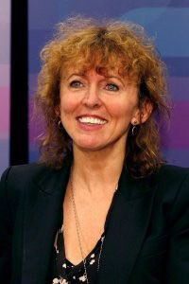
Dr. Bernadette Lynch is an academic and museum professional, with twenty-five years experience in museum senior management in Canada and the UK, most recently as Deputy Director of the Manchester Museum. She is now an internationally known consultant, lecturer, writer and researcher specialising in museum engagement, participation and shared authority.

Photo by Steve Devine, Manchester Museum

11.30–12.30 Break Out Session 1e
Title: Curators, collections and communities: understanding the multiple meaning of objects
This workshop, delivered by Caroline Reed and Marilyn Greene, will introduce the Revisiting Collections Project and the newer Stories of the World Project. Revisiting Collections is an innovative methodology developed by the Museums, Libraries, Archives Council (MLA) and Collections Trust to support museums and archives to open up their collections for scrutiny by community groups and external experts to reveal and record ‘hidden histories’ and to build and share a new understanding of the multilayered meaning and significance of objects and records. After an introduction to this project by Caroline Reed, Marilyn will share the findings of audience consultation work undertaken for this project at the V&A in 2006.

Participants will be asked to bring a picture and some information about an object of personal significance and join a practical session to ‘revisit’ their object.

Speaker: Caroline Reed, Museum and Heritage Consultant
Caroline Reed is an experienced curator and consultant. With MLA and the Collections Trust she has led development of the Revisiting Collections framework, empowering museums and archives to work directly with communities and build and share a new understanding of the multi-layered meaning and significance of objects and records.

Speaker: Marilyn Greene, Intercultural Interfaith Officer, V&A
Marilyn Greene has worked in the Learning Department of the V&A for over 10 years on adult and community projects and programming of events. She worked as the Intercultural/Interfaith Officer for the three year V&A HLF Capacity Building and Cultural Ownership and is now the manager of the adult intercultural programme and of ‘Inspired by’, the V&A competition. She has worked as a freelance guide and curator of local history.

Break Out Session: Museum Tours & Collections Workshops

13.30–14.30 Break Out Session 1a
Title: Discover the Muslim Heritage Trail
A new version of the 1001 Inventions exhibition will launch at the Science Museum in January 2010. This will be the first time that the Science Museum has addressed this theme in over 30 years since the Festival of Islam that took place across several London museums in 1976. This tour will explore the considerations involved in developing this new type of display and review the strategies deployed by the exhibition developers to facilitate positive audience engagement with the content
in the effort to optimise visitor impact. The intellectual challenges and institutional considerations in hosting this type of display will be discussed and the extent of anticipated success will be gauged.

To synergise with the 1001 Inventions exhibition, the Science Museum will also seek to develop a small standalone display on the theme of Islamic Science using objects from its own collections. A personal tour of this display will be included. An exploration of the challenges involved in attempting to construct a coherent narrative based on a limited number of objects will be a revealing for museum professionals seeking to enhance the representation of other civilisations that are often missing from the conventional depiction of the history of science.

Guide: Yasmin Khan, Curator Team Manager, Science Museum
Yasmin works as the Curator Team Manager at the Science Museum and is responsible for the operational management of museum curators who use the museum's peerless scientific collections to research and develop content to create new exhibitions, galleries and other cultural products. Yasmin has been with the Science Museum for nine years; first as a science communicator (Explainer) based in the interactive galleries, then as the Exhibition Co-ordinator which involved managing the development and delivery of new exhibitions and galleries. She studied and trained as a bio-scientist to degree level, has a Masters degree in Science and Culture and is an experienced freelance writer. Yasmin was the Project Leader for the '1001 Inventions: Muslim Heritage in our World' exhibition. She led the project from conception, development through to delivery until it's inaugural launch at the Museum of Science and Industry in Manchester in 2003 where it subsequently toured across the UK and now globally. A new version of the 1001 Inventions exhibition will launch at the Science Museum in January 2010 and Yasmin will be acting as the Science Museum's in-house content advisor.

13.30–14.30 Break Out Session 1b
Title: Fashion & Social Class
This informal and personal tour of the V&A's Fashion Gallery will reflect both on the curatorial decisions underlying the Museum's collection and its display, and the uses that might be made of it by scholars and students interested in the relationship between dress and diverse identities.

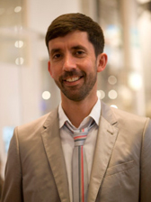
Guide: Christopher Breward, Head of Research, V&A
Christopher is Head of the Research Department which supports research underpinning exhibitions, publications and collection-related projects at the V&A. He took his undergraduate degree in the History of Art at the Courtauld Institute and completed postgraduate study on the joint V&A/Royal Collage of Art Programme in the History of Design and is a Fellow of the Royal Society of Arts.
He has held lecturing posts in the History of Art and Design at Manchester Metropolitan University and the Royal College of Art. Before working at the V&A he was Head of Research at London College of Fashion, University
Christopher Breward
of the Arts, London, where he still holds a Visiting Professorship. Christopher sits on the Editorial Boards of the journals 'Fashion Theory' and the 'Journal of Design History' and the Advisory Boards of the 'Journal of Visual Culture in Britain', 'RXFutures' (University of Reading) and 'The Happy
Hypocrite' (Arts Council/Bookworks). He is also General Editor of the Manchester UniversityPress Series 'Studies in Design'. He is an active member on numerous key committees, including the AHRC Peer Review Panel for Visual Arts and Media; the Pasold Research Fund; the Advisory Board of the Raphael Samuel Centre for Metropolitan Studies.
Christopher's personal research interests lie in the field of fashion history and he has published widely on fashion's relation to masculinity, metropolitan cultures and concepts of modernity. Ongoing projects include a collaborative project (Fashioning Diaspora Space) with Royal Holloway, University of London on British Asian fashion in the nineteenth and twenty-first centuries funded by the AHRC's 'Diasporas, Migration and Identity' Programme.

13.30–14.30 Break Out Session 1c
Title: Collections through the prism of sexuality
Lesbian, gay, bi, trans and queer histories are a new research subject area for museums. Over the past few generations attitudes to sexuality have undergone a seismic shift but museums have been slow to reflect these changes. Since 2006 the V&A LGBTQ Network has sought to enable an overwriting of lesbian and gay histories onto the V&A collections, researching objects and the histories that surround them whilst also presenting a more immediate and audience focussed programme of events, talks and film screenings.

As successful as any such programme may be in broadening audiences and extending diversity, such an approach is necessarily founded upon essentialist notions of sexual identity and reflects a central contradiction at the heart of sexuality as a marker of audience: the desire to eradicate discrimination is always in tension with the desire to enshrine difference.

This paper investigates the ways in which sexualities may be presented as significant to an understanding of objects that equally accommodates these tensions, allowing also for the ways in which visitors themselves understand and make sense of objects on the basis of their own identities and lived experience.

Speaker: Oliver Winchester, Assistant Curator, V&A
Oliver Winchester is Assistant Curator of a forthcoming V&A exhibition Postmodernism: Style & Subversion 1970–1990 and Head of the V&A LGBTQ Network. Oliver joined the V&A in 2006 and previously worked on Contemporary Programmes. Before joining the V&A he worked at Christie’s and the Barbican Art Gallery.

13.30–14.30 Break Out Session 1d
Title: Prisoners quilts at the V&A
Since 2006 Sue Prichard, V&A Curator, has been working closely with the prison charity Fine Cell Work on a major commission for a quilt designed and made by the prisoners of HMP Wandsworth, which will be displayed in the Spring 2010 Quilts exhibition. In this session, Sue Prichard discusses the collaboration which included visiting HMP Wandsworth on a regular basis, lecturing on the collection, facilitating group discussions regarding the design process and providing images and publications for inspiration. 65 men were involved in the design and making of the quilt which will be juxtaposed with the ‘HMS Rajah Quilt’, the only transportation quilt in a public collection, made by female convicts transported to Van Diemen’s Land (present day Tasmania) in 1841.

Guide: Susan Prichard, Curator, Quilts 1700-2010, V&A
Sue Prichard joined the V&A in 2001 from Tate. She is currently working on a major exhibition Quilts 1700–2010: Hidden Histories, Untold Stories (20 March – 4 July 2010). She holds an MA in Museum Studies from the Institute of Archaeology, University College London, and is a Fellow of the Royal Society of Arts.

13.30–14.30 Break Out Session 1e
Title: Traces of the Trade
Highlights from the series of V&A Gallery trails which sought to reveal the links between the transatlantic slave trade and art and design. Peter Ashan, Museum Educator, V&A introduces objects with hidden and often unexpected links to slavery and Helen Mears, Former African Diaspora Research Fellow, V&A discusses how the trails formed part of a wider institutional initiative to address hidden histories embedded in the V&A’s permanent collections.

Guide: Peter Ashan, Museum Educator
Museum Educator with the V&A since 2004. From 2007 Peter has worked with diverse audiences on the Traces of the Trade and Uncomfortable Truths trail.

Guide: Helen Mears, Keeper of World Art, Royal Pavilion & Museum, Brighton & Hove (Previously Researcher of African Collection, V&A)
Helen Mears is the Keeper of World Art at Royal Pavilion & Museums, Brighton & Hove. Previously she was African Diaspora Research Fellow at the Victoria and Albert Museum. The post was part of the Capacity Building and Cultural Ownership initiative funded by the Heritage Lottery Fund.

13.30–14.30 Break Out Session 1f
Title: Faith Tour
This session will explore the ideas and processes behind developing three new cultural/faith galleries in the V&A. The curators involved in the Sacred Silver and Stained Glass Gallery, Jameel Gallery of Islamic art and the Robert H.N.O Family Foundation Gallery of Buddhist Sculpture will introduce each gallery. They will talk about the concepts for the new galleries, what was involved, who they consulted with and how they felt their aims were achieved. The Head of Interpretation and Evaluation will discuss the galleries interpretative concepts and Marilyn Greene will talk about the accompanying educational programmes.

Guide: Marilyn Greene, Intercultural Interfaith Officer, V&A
Marilyn Greene has worked in the Learning Department of the V&A for over 10 years on adult and community projects and programming of events. She worked as the Intercultural/Interfaith Officer for the three year V&A HLF Capacity Building and Cultural Ownership and is now the Manager of the adult intercultural programme and ‘Inspired by’, the V&A competition. She has worked as a freelance guide and curator of local history.

Guide: Juliette Fritsch, Head of Gallery Interpretation, Evaluation and Resources, V&A
Juliette Fritsch has been working in museum and site interpretation and visitor research for the last ten years, since graduating from the University College London Institute of Archaeology Masters programme in Cultural Heritage Management. She is Head of Gallery Interpretation, Evaluation and Resources at the V&A, where her team is responsible for all education and interpretation work on new gallery projects, visitor research across the museum, and the artists in residence programmes. She has previously worked for English Heritage and Historic Royal Palaces. She is a Fellow of the Royal Society of the Arts (FRSA), and a doctoral student in the Faculty of Culture and Pedagogy at the Institute of Education.

Guide: Marian Rosser-Owen, Islamic gallery guide, V&A Curator
Guide: John Clarke, Buddhist gallery guide, V&A Curator
Guide: Tessa Murdoch, Sacred Silver gallery guide, V&A Curator

13.30–14.30 Break Out Session 1g
Title: My V&A: Personal stories through the V&A collections
See the V&A’s collections from a different perspective. Let a refugee be your guide, taking you on a unique tour of the Museum as objects in the galleries act as a springboard for their own highly personal stories.

Guide: Refugee led tour

13.30–14.30 Break Out Session 1h
Title: Throne of Ranjit Singh & other collections: Curatorial & community perspectives
The first Sikh Maharaja of the Panjab, the former Mughal province now divided between India and Pakistan, was Ranjit Singh. He ruled from 1801 until his death in 1839, and extended his lands to include Kashmir. Though famously modest in his own personal appearance, he used the emblems of kingship to great effect and commissioned a Golden Throne
that is now preserved in the V&A. This session will discuss the history of the court, and the history of the throne itself, which was taken by the British at the annexation of the Panjab in 1849 and shipped to London. It will also explore any similarities and differences of interpretation by Sue Stronge, curator in the Asian department at the V&A and Harbinder Singh, founder of Britain’s first Sikh heritage based organisation.

Speaker: Sue Stronge, Senior Curator: Asia, V&A
Susan Stronge is a Senior Curator at the Victoria and Albert Museum. She was curator of the acclaimed V&A exhibition, The Arts of the Sikh Kingdoms in 1999, and lectures frequently on the arts of the Sikh court of Panjab.

Speaker: Harbinder Singh, Director, Anglo Sikh Heritage Trail
Harbinder Singh is the founding Director of the Maharaja Duleep Singh Centenary Trust, Britain’s first Sikh heritage based organisation. He has overseen the conception and launch of the Anglo Sikh Heritage Trail which now covers the UK.

Harbinder Singh

Afternoon Session: Drivers for Change

14.55–16.10
Title: Workforce diversity: positive action and other steps towards lasting cultural change
This session will review the history of workforce diversification in UK museums and will consider what steps still need to be taken. The session will include presentations from Lucy Shaw and Helen Wilkinson who will assess the impact of workforce diversification initiatives from the Museums Association, and will include a panel discussion with leading diversity practitioners from within the museum sector and beyond. The session will include consideration of the new public policy context for workforce diversification, and will include discussion of a new initiative designed to improve the representation of people from low-income backgrounds in the museum sector.

Chair: Sandy Nairne, Director, National Portrait Gallery
Sandy Nairne is Director of the National Portrait Gallery, London. He is the author of The Portrait Now (2006) and was formerly Director of Programmes at Tate.

Speaker: Lucy Shaw is a consultant who specialises in workforce development. Since 2002, Lucy has led the Museums Association’s Diversify programme and is currently coordinating the MA’s Support and Challenge programme, funded by MLA, which aims to enable museums to initiate organisational change and development by introducing more inclusive working practices.

Speaker: Helen Wilkinson is a consultant specialising in research, policy and project development. Helen started her museum career as a curator and later spent seven years at the Museums Association, where she was the author of the major 2005 report, Collections for the Future, which has helped the sector rethink approaches to museum collections.

Speaker: Joseph Harker

Speaker: Praveen Herat is a freelance consultant to the museums and heritage sector. He was formerly a Management-Level Trainee on the Museums Association’s Diversify Scheme, seconded to the Royal Pavilion & Museums in Brighton & Hove. Before joining the cultural sector, he worked in the international development and UK charity sectors.

16.15–17.15
Title: Future drivers for change
A panel of museum and heritage professionals will identify key internal and external drivers for change; drawing on the experience of the last decade but taking account of the changing local, national and globalised context in which we operate and, at the same time, projecting ourselves firmly into the future. It will also be a chance to explore and summarise some of the key issues that have arisen from the conference.

Chair: Baroness Lola Young, Freelance Arts and Heritage Consultant

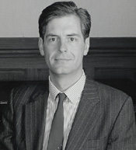
Panel member: Mark Jones, Director, V&A
Mark Jones became Director of the Victoria and Albert Museum in May 2001. Before this he was Director of the National Museums of Scotland, from 1992, and for the previous eighteen years he was at the British Museum in the Department of Coins and Medals. He is an expert on the history of medallic art and, when at the British Museum, organised the exhibition FAKE? The Art of Deception, which attracted critical acclaim for its combination of 'broad popular appeal with the grandest kind of scholarship'.
Mark Jones
In Scotland, he won a reputation as one of Britain’s most talented museum directors following the opening of the award-winning new Museum of Scotland in 1998. Both the striking building by Benson & Forsyth (Stirling Prize runner up 1999) and the displays were well received (the latter winning 22 awards).
He is Chairman of the National Museum Directors’ Conference, a trustee of the National Trust, the Gilbert Collection, and The Pilgrim Trust; is a member of the Court and Council of the Royal College of Art; Vice President of the British Art Medal Society and the Kensington & Chelsea Decorative & Fine Arts Society; and a patron of the Embroiderer’s Guild.
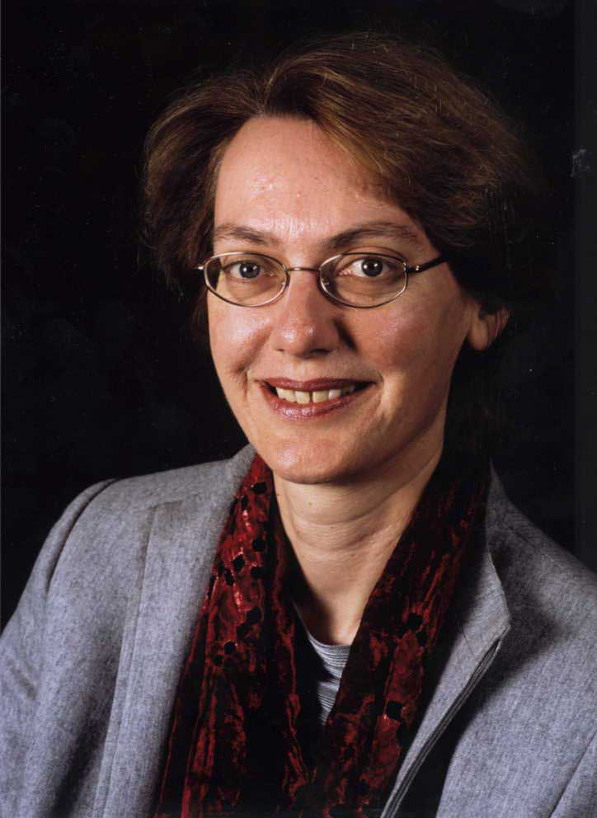
Panel member: Carole Souter, Chief Executive, Heritage Lottery Fund
Chief Executive of Heritage Lottery Fund and National Heritage Memorial Fund since 2003.

More than 30 years experience of policy development and management roles in the public sector. Previously Director of Planning and Development at English Heritage. Experienced mentor and Trustee of charitable organisations.

Carole Souter

Panel member: (TBC) Julien Anfrans, Director General of the International Council of Museums (ICOM), and President of the International Committee of the Blue Shield (ICBS)
On 22 January, the International Committee of the Blue Shield appointed Julien ANFRUNS as the Director General of the International Council of Museums (ICOM), and President of the International Committee of the Blue Shield (ICBS). Before taking up his appointments at ICOM and ICBS, Mr Anfruns was Director of Financial and Legal Affairs at the Louvre Museum (2005–2008), where he was involved in the museum's strategic development missions both in France and abroad. Prior to that, he was in charge of Economic and Financial Affairs at the French Ministry of Culture and Communication (2002–2005) and occupied diplomatic posts at the United Nations (New York), in Finland and in Estonia.

Panel member: Janet Marstine, Director, Institute of Museum Ethics, Seton Hall University, New Jersey
Janet Marstine is Director of the Institute of Museum Ethics at Seton Hall University for which she received a three-year Institute for Museum and Library Services Grant. She is editor of New Museum Theory and Practice: An Introduction (2005) and is currently editing Routledge Companion to Museum Ethics: Redefining Ethics for the Twenty-First Century Museum.

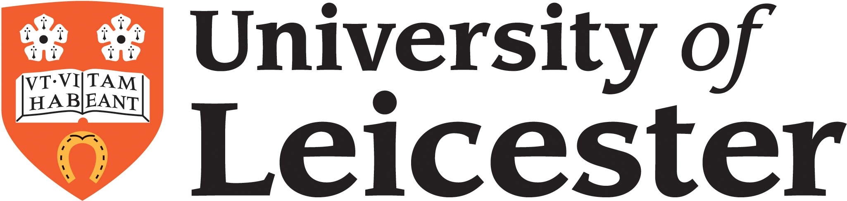

Jointly organised with University of Leicester’s School of Museum Studies

